**Your Frontend is ☠️ ⚠️ Let's measure its impact with CO2.js**

<https://www.youtube.com/watch?v=lSi0new5mDM>



**What's Wrong With This Picture?**

When we think about design and sustainability, what is the first thing that comes to mind as being inefficient on this screen?

**The White Background**

White screens require monitors to use more energy. Black is better.



**The Colors & Images**

Historically, creating green pigments was chemically intensive. In digital, darker colors are still more energy-efficient. Unnecessary images also add to the data load.

**Your Frontend is Killing (the Planet)**

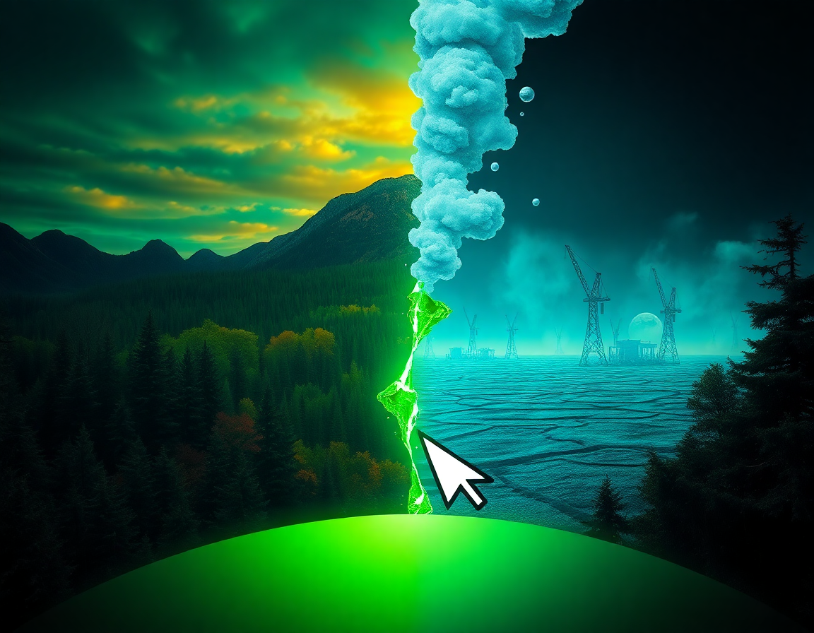

We need to deep-dive into how we can monitor our frontend applications to reduce their environmental impact. It starts by being aware of the patterns we create as developers.

**Energy Patterns for Sustainable Frontends**

As frontend designers and developers, we must be aware of the impact of our choices. These patterns can guide us toward becoming more sustainable developers.

**Dark UI & Colors**

Favor dark themes and energy-efficient colors to reduce screen power consumption.

**Connectivity**

Consider the energy use of different connection types like Wi-Fi vs. cellular (GSM).

**Asset Size**

Reduce the size of images, scripts, and other assets to minimize data transfer.

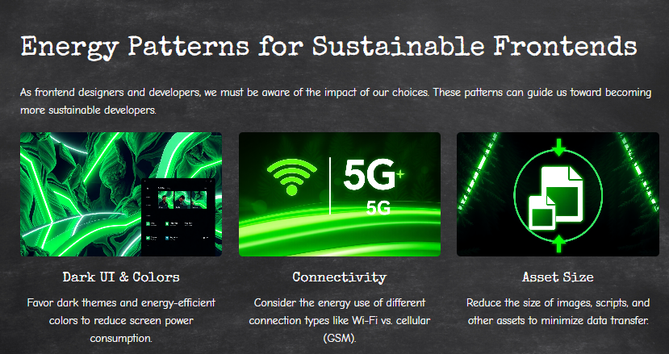

**What's In It For Me? (Agenda)**

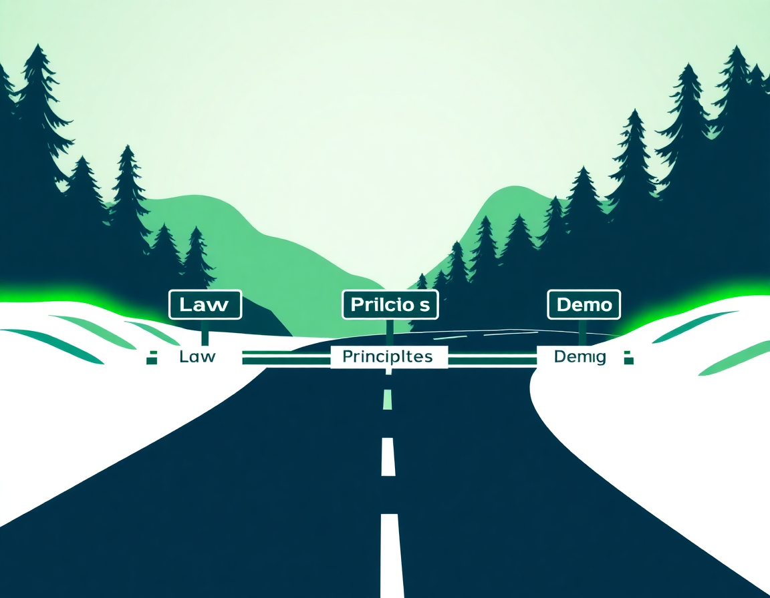

* The Incoming Law: Why we can't ignore this anymore.
* The Green Software Principles: A framework for action.
* CO2.js in Action: A live demo on monitoring your application.

**The Urgency: Why We Must Act Now**

**The consequences of inaction on climate change in Europe are severe:**

**Wildfires**

An additional 50 million people will be exposed to high wildfire danger each year.

**Heatwaves**

Will cause 90,000 more deaths every year than now.

**Flooding**

Over a million more people will be flooded in coastal and river areas.

As developers, we are part of the system, and we have a role to play in the solution.

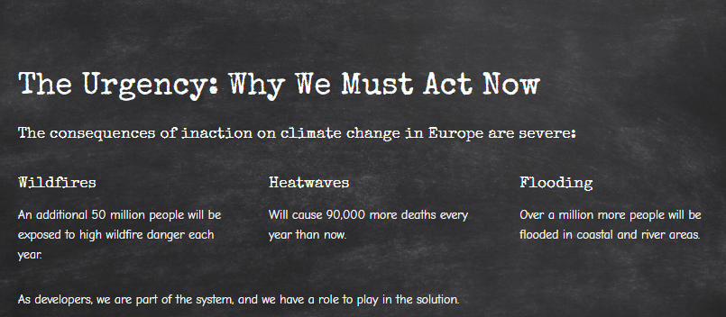

**The Legal Imperative: CSRD**



**Corporate Sustainability Reporting Directive**

* Applies to companies with more than 250 employees.
* Mandates the delivery of detailed sustainability reports, similar to financial reports.
* Increases transparency on what companies are doing to address their environmental impact.
* Your company needs to show what you are doing in the backend and across the entire value chain.

**The Scale of the Problem: IT vs. Aviation**



The total CO2 pollution from the entire IT industry is nearly the same as the aviation industry. Yet, the conversation around reducing IT's footprint is just beginning.

**he 8 Green Coding Principles**

* Be aware of your CO2 emissions.
* Choose your energy source (sun, wind).
* Consider your hardware's lifecycle.
* Utilize the cloud (usually better).
* Aim for fewer connections to other systems.
* Time your batch jobs for when energy is greenest.
* Monitor your application's impact.
* Focus on end-user efficiency.

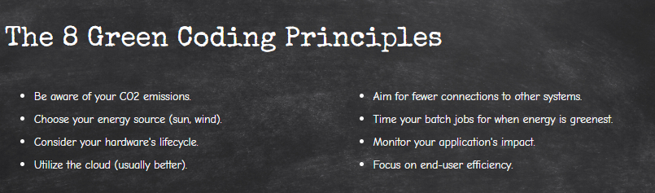

**Where is the Biggest Impact?**

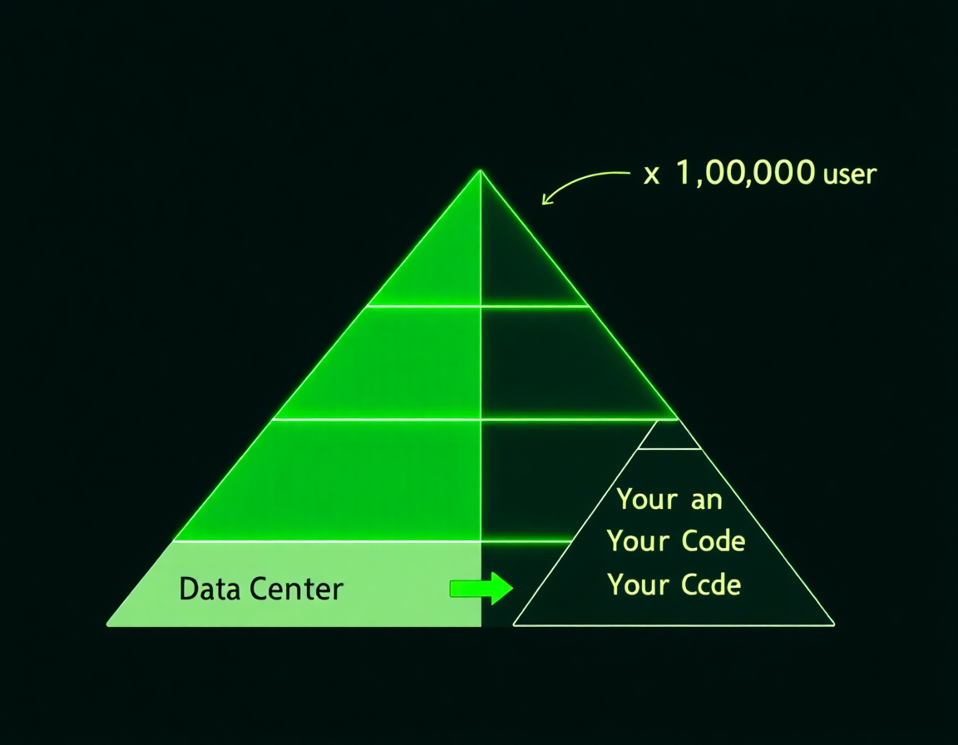

It's often thought that our code has the least impact compared to data centers. However, when a tiny code improvement is multiplied by millions of users, the pyramid inverts. Your code can make a massive difference.

**Quick Measurement: Website Carbon**

A simple way to get a baseline for your website's performance is using a tool like websitecarbon.com. It analyzes your site and provides a grade.

**Before Optimization**

Our site initially scored an 'F' due to large images and inefficient caching.

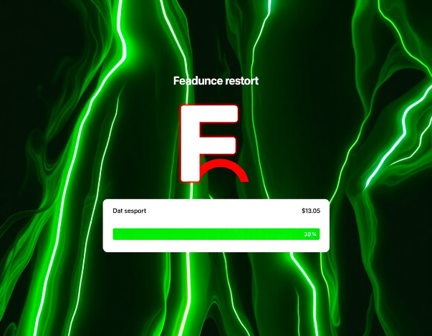

**After Optimization**

By reducing image sizes and improving caching, we improved to a 'C'. There's still room to get to an 'A'!

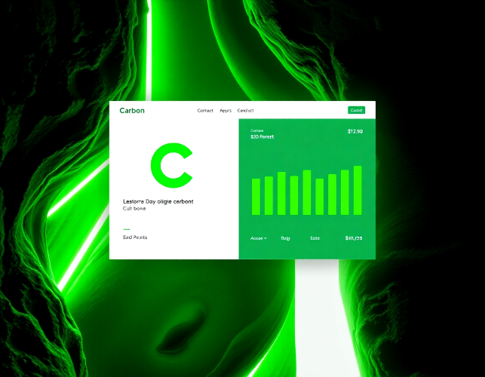

**The Dependency Dilemma**



You can install the whole world with npm or Maven, but should you? Be mindful of the dependencies you add. Every package contributes to the final bundle size and potential energy consumption.

* Think about what you're installing.
* Regularly audit your dependencies.
* Delete what you are not using.

**Introducing CO2.js**

Developed by The Green Web Foundation, CO2.js is a JavaScript library that helps you measure the environmental impact of your application by converting data transfer (bytes) into CO2 emissions (grams).

**Per Byte**

Calculate emissions based on data size.

**Per Visit**

Estimate the carbon cost of a single user visit.

**Per Page**

Analyze the impact of specific pages in your app.

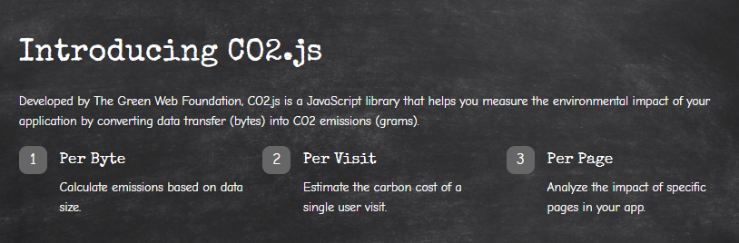

**Understanding CO2.js Models**

**One-Byte Model**

The simpler model. It only checks the data transfer to your backend systems and calculates emissions based on data center energy usage.

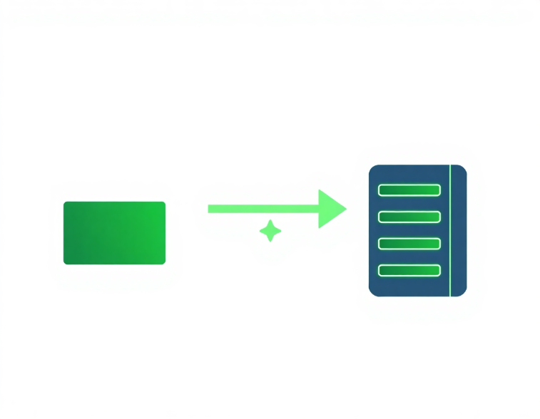

**SWD Model (Sustainable Web Design)**

The comprehensive model. It accounts for the whole chain: end-user device energy, network transfer, data center, and even the production stage of hardware.

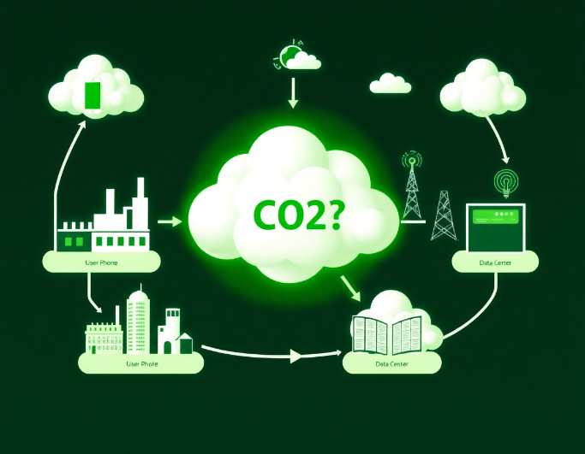

**Demo Tech Stack**

We will build a monitoring dashboard using a modern, efficient tech stack.

**React & Next.js**

For building the frontend application.

**Mantine**

A component library for a clean UI.

**TypeScript**

Studies show typed languages can be more sustainable due to fewer runtime errors and better optimization.

**Axios & Node.js**

For making calls to a simple backend server.



**Demo Part 1: The Basics**

**Average Grid Intensity**

Using `averageIntensity`, we can check the carbon intensity of a country's electricity grid. Belgium appears more sustainable than the Netherlands in this example.

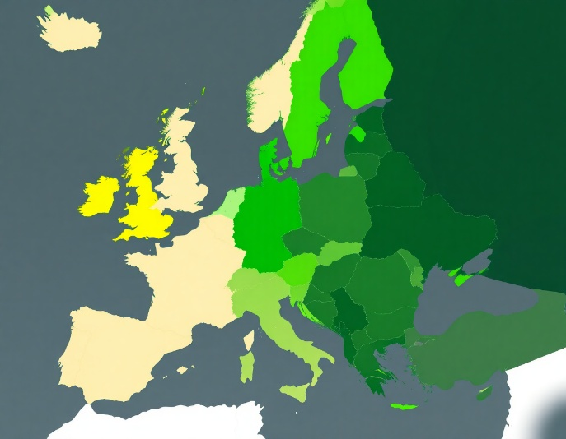

**Is My Host Green?**

The `hosting.check` function allows us to verify if a domain is hosted on servers powered by renewable energy. Google.com is green, but localhost is not.



**Demo Part 2: Measuring A Visit**



**Calculating CO2 Per Visit**

We use the `swd` model from CO2.js. By fetching the file size of our application from a server, we can transform that data into a real CO2 emission figure for a single visit.

This gives us a baseline: `0.86 grams of CO2 per visit`. Now, what happens when we scale this?

**Demo Part 3: The Shocking Comparison**

Let's make the impact tangible by comparing emissions to kilometers driven. At 10,000 visits, our small site is equivalent to driving 200 km.

**Now, let's add one 20MB uncompressed image:**

**With 20MB Image**

The equivalent driving distance jumps to over 1500 km! We can drive to Spain just by loading an uncompressed image for 10,000 users.

**With Compressed Image**

By simply compressing the image, the distance drops to just 92 km. A tiny change with a massive impact.

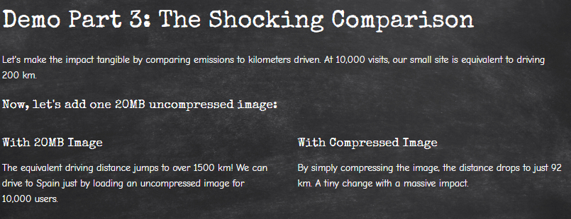

**Key Takeaways & Your Next Steps**

**Learn More**

Enroll in the free Green Software Foundation course to deepen your knowledge.

**Choose Wisely**

Use eco-friendly tools like the Ecosia search engine and choose data centers that run on renewable energy.

**Read Up**

Explore books on Building Green Software and Sustainable Software Architecture.



**Final Thoughts**

* **Choose an eco-friendly architecture:** The biggest decisions have the biggest impact.
* **Measure everything:** Use tools like CO2.js or Kepler to understand your footprint.
* **Think of the small enhancements:** A compressed image or a removed package, when scaled, can save tons of CO2.

**Thank You!**

